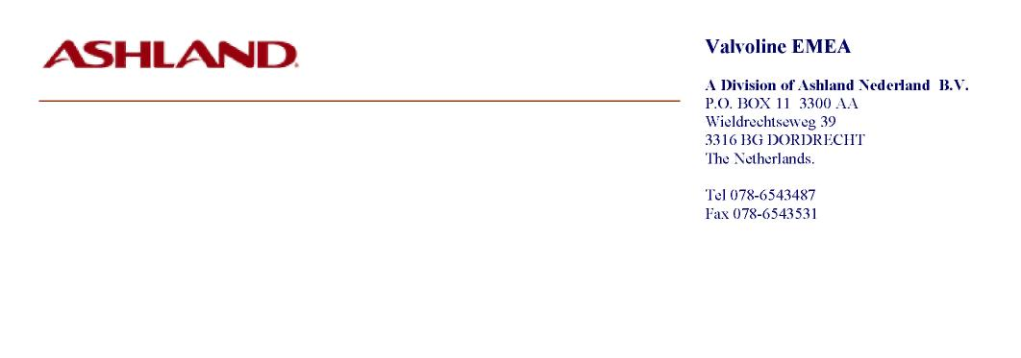
Product Composition for Customs Purposes.

Product:
TECTYL GLASHELDER/KLAR -Spray-VE20055.

Date:
Nov 24, 2010

COMPONENTS; | WEIGHT % | REMARKS:
White spirit | 26 – 30
Calcium soap oxidized petrolatum | 22 – 26
Petroleum sulfonate | 3 – 4
Mineral oil | 0.8 – 1.1
Butyl cellosolve | 1 – 1.2
Amine corrosion inhibitor | 0.3 – 0.5
Propellant | 42.0 | Propane/butane
