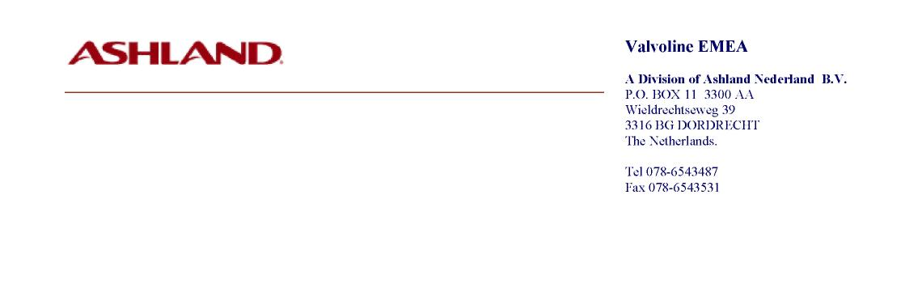
Product Composition for Customs Purposes.
Product: TECTYL SUPERWAX -Spray-, VE20095
Date: Nov 17, 2010

COMPONENTS; | WEIGHT % | REMARKS:
White spirit | 22 – 26
Calcium soap oxidized petrolatum | 20 – 24
Petroleum sulfonate | 3 – 4
Mineral oil | 0.8 – 1.1
Butyl cellosolve | 1 – 1.2
Amine corrosion inhibitor | 0.3 – 0.5
Propellant | 48.0 | Propane/butane
